Change Order Request
December 14, 2015

Merrill Gardens at Ballard, LLC
111 N. Post, Suite 200
Spokane, WA 99201
Attn: Bill Robinson

Re: Merrill Gardens at Ballard – Change Order Request #07 – RFI-159 Condenser Rack Drain

Bill,

Please see cost breakdown below to add a condensate drain for the walk-in refrigerator condenser rack per RFI-159. Note that the sheet metal pan has been excluded. Please issue an official Change Order at your earliest convenience. Let me know if you have any questions or require further information. Thank you.

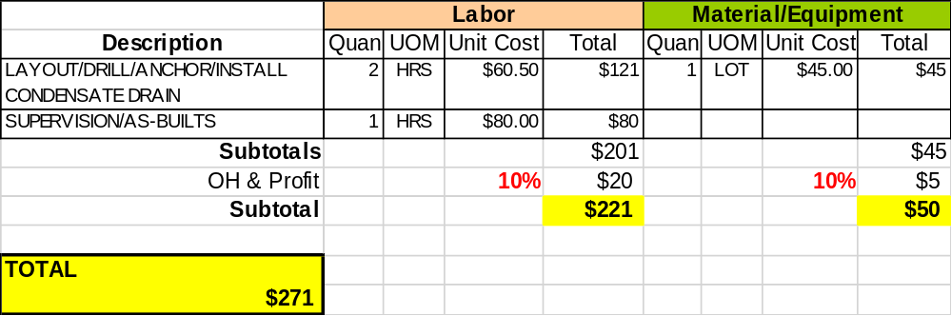

Sincerely,
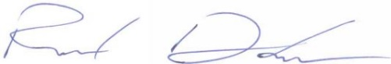
Richard Donelson
Project Manager / Estimator
richd@owpllc.net
425-591-4296 cell

